Novel biomarker TyHGB Index Outperforms Conventional Anthropometric Indices for Mortality Prediction in MASLD: A National Cohort
Tien Manh Huynh, Doan Thi Nha Nguyen, Duc Trong Quach
Introduction
Metabolic dysfunction-associated steatotic liver disease (MASLD), the new consensus designation for the spectrum previously captured by non-alcoholic fatty liver disease (NAFLD), is now the most common chronic liver disease worldwide and a major contributor to the global cardiometabolic burden. MASLD is intimately linked to insulin resistance, type 2 diabetes mellitus, atherogenic dyslipidaemia, hypertension and abdominal obesity, and individuals with MASLD are at substantially increased risk of cardiovascular morbidity and mortality, which exceed liver-related causes of death as demonstrated in several large prospective cohorts.
Because cardiovascular disease drives much of the excess mortality in MASLD, simple and widely available prognostic markers that capture the underlying cardiometabolic milieu are clinically attractive. The triglyceride-glucose (TyG) index, derived from fasting triglycerides and fasting plasma glucose, is a validated surrogate of insulin resistance and has been associated with incident diabetes, atherosclerotic cardiovascular disease and adverse outcomes across diverse populations. However, unidimensional metabolic indices may not fully reflect the multi-system pathophysiology of MASLD, in which haematological and erythrocyte-related parameters also play an emerging role.
Haemoglobin concentration reflects iron metabolism, hypoxic stress, hepcidin signalling and the metabolic state of erythrocytes, all of which interact with hepatic steatosis, oxidative stress and endothelial function. Higher haemoglobin levels have been linked to insulin resistance, metabolic syndrome, increased hepatic iron stores and cardiovascular events, while haematocrit and red cell indices are increasingly recognised as integrative cardiometabolic markers. Combining the TyG index with haemoglobin into a composite triglyceride-glucose-haemoglobin (TyHGB) index may therefore offer a more integrative reflection of the insulin-resistance-dyslipidaemia-haematology axis that drives cardiometabolic risk in MASLD.
Despite the conceptual appeal of the TyHGB index, its prognostic value in patients with MASLD has not been systematically characterised in a nationally representative cohort with long-term mortality follow-up. In particular, it remains unclear whether TyHGB independently predicts all-cause and cardiovascular mortality after accounting for established demographic and clinical risk factors and other anthropometric or metabolic indices, whether its association with mortality is linear or follows a non-linear dose-response pattern, and to what extent the relationship is mediated by downstream metabolic intermediates such as serum uric acid. Although preliminary studies have evaluated TyHGB in other cardiometabolic contexts, its independent prognostic significance specifically in MASLD — a population with distinct hepatic, metabolic and haematological interactions — has not been established.
Using data from the National Health and Nutrition Examination Survey (NHANES) with linkage to the National Death Index, we therefore aimed to: (i) quantify the independent association of TyHGB with all-cause and cardiovascular mortality in adults with MASLD; (ii) examine the dose-response shape of this relationship; (iii) compare the discriminative and reclassification performance of TyHGB with that of other anthropometric indices (A Body Shape Index [ABSI], Weight-adjusted Waist Index [WWI] and Waist-to-Height Ratio [WHtR]); (iv) explore mediation through serum uric acid; and (v) translate the findings into a validated prognostic nomogram assessed by calibration and decision-curve analysis.
.
Materials and Methods
Study design and population
We performed a prospective cohort analysis using data from the National Health and Nutrition Examination Survey (NHANES), a complex, multistage probability survey conducted by the National Center for Health Statistics (NCHS) of the US Centers for Disease Control and Prevention (CDC) to assess the health and nutritional status of the non-institutionalised civilian population of the United States. NHANES protocols were approved by the NCHS Research Ethics Review Board, and all participants provided written informed consent at the time of survey enrolment. Because the present analysis used de-identified, publicly available NHANES data, no additional institutional review board approval was required.
Adult participants (aged ≥ 18 years) with available fasting laboratory measurements, anthropometric data and mortality linkage were considered for inclusion. Pregnant women, participants with significant alcohol consumption, viral hepatitis B or C infection, or other identifiable causes of secondary hepatic steatosis, and those missing key exposure variables (triglycerides, fasting glucose, haemoglobin) or follow-up information were excluded. The final analytic sample comprised 7,510 adults with MASLD, who were stratified into quartiles (Q1-Q4) according to the TyHGB index for all subsequent analyses.
Definition of MASLD
MASLD was defined in accordance with the 2023 multi-society consensus nomenclature, requiring evidence of hepatic steatosis together with at least one cardiometabolic criterion (overweight or central adiposity, dysglycaemia, hypertension, atherogenic dyslipidaemia or low HDL-cholesterol), in the absence of significant alcohol intake or other identifiable causes of fatty liver. Hepatic steatosis was ascertained using the imaging-based or biomarker-based criteria available in the relevant NHANES cycles, consistent with prior MASLD operationalisations of NHANES data. [Author query: please confirm the exact MASLD ascertainment method (e.g., FibroScan-controlled attenuation parameter cut-off vs. US Fatty Liver Index) used in your analytic pipeline so that this paragraph matches the analysis code.]
Definition of the TyHGB index and comparator anthropometric indices
The triglyceride-glucose (TyG) index was calculated as ln[fasting triglycerides (mg/dL) × fasting plasma glucose (mg/dL) / 2]. The triglyceride-glucose-haemoglobin (TyHGB) index was defined by integrating the TyG index with haemoglobin concentration, in line with previously published TyG-haemoglobin composite formulations. [Author query: please confirm the exact arithmetic form of the TyHGB index used in your code (for example, TyG × haemoglobin or TyG × haemoglobin / 100), so that the formula reported in the manuscript exactly matches the analytic implementation.] For comparison, three established anthropometric indices were also computed: A Body Shape Index (ABSI), the Weight-adjusted Waist Index (WWI) and the Waist-to-Height Ratio (WHtR), each derived using standard, published formulas. To enable direct head-to-head comparison across indices, all four exposures were Z-score standardised (mean = 0, SD = 1) so that hazard ratios are interpretable per 1-SD increment.
Mortality outcomes and follow-up
The two prespecified primary outcomes were all-cause mortality (ACM) and cardiovascular mortality (CVM). Mortality status and underlying causes of death were obtained by probabilistic linkage of NHANES participants to the National Death Index (NDI) public-use file, with cause-of-death classification based on the International Classification of Diseases, Tenth Revision (ICD-10). Cardiovascular deaths were defined using the standard NCHS analytical groupings for diseases of the heart and cerebrovascular disease. Follow-up time was calculated from the date of survey examination to the date of death or to the end of mortality follow-up, whichever occurred first.
Covariates
Pre-specified covariates were selected based on biological plausibility and prior evidence as potential confounders of the TyHGB-mortality relationship. They included age, sex, race/ethnicity (non-Hispanic White, non-Hispanic Black, other races), education level, marital status, family income-to-poverty ratio, body mass index, waist circumference, smoking status, alcohol intake, self-reported diabetes mellitus and hypertension, and laboratory measures including fasting plasma glucose, fasting insulin, glycated haemoglobin (HbA1c), homeostatic model assessment for insulin resistance (HOMA-IR), total cholesterol, HDL- and LDL-cholesterol, triglycerides, alanine aminotransferase (ALT), aspartate aminotransferase (AST), gamma-glutamyl transferase (GGT), serum uric acid, serum creatinine and estimated glomerular filtration rate. Flowchart of study is Figure S1.
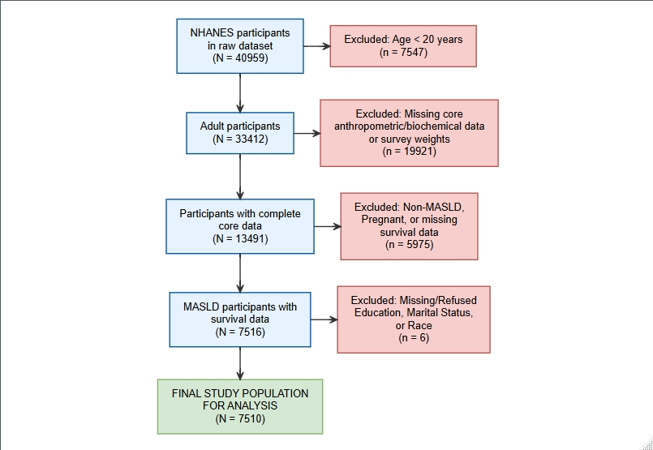
Figure S1. Flowchart of study

STATISTICAL METHODS
All statistical analyses were conducted following the analytical guidelines set by the Centers for Disease Control and Prevention (CDC), utilizing appropriate sample weights, primary sampling units, and strata to account for the complex, multistage probability sampling design of the NHANES. To handle missing data and minimize potential bias, multiple imputation using chained equations (MICE) via predictive mean matching was employed for covariates with missing values. Baseline characteristics of the study population were stratified by TyHGB quartiles. Continuous variables were expressed as survey-weighted means with standard deviations (SD), and categorical variables as unweighted counts with survey-weighted percentages. Baseline differences across quartiles were assessed using the design-based Kruskal-Wallis test for continuous variables and the Rao-Scott Chi-square test for categorical variables.
Survey-weighted Kaplan-Meier survival curves were plotted, and differences between strata were compared using the weighted log-rank test. To evaluate the independent prognostic value of the TyHGB index for all-cause (ACM) and cardiovascular mortality (CVM), survey-weighted Cox proportional hazards regression models were constructed to calculate hazard ratios (HRs) and 95% confidence intervals (CIs). For direct head-to-head comparisons of prognostic strength among different anthropometric indices, all indices were Z-score standardized, allowing HRs to be interpreted per 1-SD increase. The potential non-linear, dose-response relationship between the TyHGB index and mortality risk was explored using restricted cubic splines (RCS) with four knots.
To provide a more comprehensive assessment of the TyHGB index, five additional analytical techniques were implemented. First, two-piecewise Cox proportional hazards regression models were used to identify inflection points of TyHGB, allowing for the calculation of specific hazard ratios below and above these thresholds. Second, a detailed mediation analysis was conducted to quantify the direct and indirect effects of the TyHGB index on mortality through multiple potential metabolic intermediates, with significance tested via the Sobel (Delta) method. Third, a sensitivity analysis was performed by excluding deaths occurring within the first 24 months of follow-up to minimize the potential for reverse causality. Fourth, the stability of the prognostic effect was verified by pooling results from multiple imputed datasets (m=5) to ensure that the hazard estimates remained robust regardless of imputation variations. Finally, E-value analysis was computed to assess the minimum strength of an unmeasured confounder required to nullify the observed association between the TyHGB index and mortality.
To assess and compare the predictive accuracy of the indices, time-dependent Receiver Operating Characteristic (ROC) curves were generated at 3-, 5-, and 10-year follow-up intervals, accounting for competing risks in cardiovascular mortality analysis. Furthermore, Harrell’s Concordance index (C-index), continuous Net Reclassification Improvement (NRI), and Integrated Discrimination Improvement (IDI) with 100 bootstrap replications were calculated to quantify the incremental predictive value of combining other indices with the base TyHGB model. Subgroup analyses were conducted to evaluate the consistency of the TyHGB-mortality association across various demographic and clinical strata, with interactions tested using the Wald test.
Finally, to translate these findings into a practical clinical tool, prognostic nomograms incorporating the TyHGB index and baseline clinical covariates were constructed to estimate the 3-, 5-, and 10-year survival probabilities for ACM and CVM. For the CVM nomogram, the Fine-Gray subdistribution hazard model was applied to account for the competing risk of non-cardiovascular deaths. The predictive accuracy of the 10-year models was internally validated via calibration plots utilizing 10-fold cross-validation. Additionally, Decision Curve Analysis (DCA) was conducted to assess the net clinical benefit of the TyHGB clinical model compared to default "treat-all" and "treat-none" strategies at the 10-year prognostic milestone.
All statistical analyses and visualizations were performed using R software (version 4.5). A two-sided p-value of < 0.05 was considered statistically significant. Missing covariates were handled via multiple imputation using the mice package, while baseline characteristics tables were formatted using gtsummary. Survival analyses, including Kaplan-Meier estimations and Cox proportional hazards regressions, were conducted utilizing the survival and survminer packages. Predictive performance evaluation and mediation analysis were facilitated by the timeROC, survIDINRI, and mediation packages, while non-linear dose-response relationships, nomogram construction, and cross-validated calibration plots were modeled using the rms package. Subgroup stability and E-value analyses were performed using the survey and EValue packages, and standardized forest plots were generated via the forestploter package.
Code at github: https://github.com/leeantran/nhanes_cox

Result
Baseline characteristics across TyHGB quartiles

Table 1: Baseline characteristics of the study population according to TyHGB quartiles
 | Overall  (N = 7510) | Q1  (N = 1878) | Q2  (N = 1879) | Q3  (N = 1879) | Q4 (  N = 1874) | p-value²
Age (years) | 47.96 (15.67) | 45.18 (15.78) | 47.53 (16.02) | 49.93 (15.57) | 49.39 (14.80) | <0.001
Gender |  |  |  |  |  | <0.001
Male | 3,472 (48.6%) | 595 (33.7%) | 858 (49.5%) | 930 (52.2%) | 1,089 (60.2%)
Female | 4,038 (51.4%) | 1,283 (66.3%) | 1,021 (50.5%) | 949 (47.8%) | 785 (39.8%)
Race |  |  |  |  |  | <0.001
Non-Hispanic White | 2,957 (64.5%) | 667 (61.9%) | 691 (62.0%) | 768 (66.5%) | 831 (67.9%)
Non-Hispanic Black | 1,601 (12.2%) | 570 (17.4%) | 453 (14.0%) | 329 (9.5%) | 249 (7.2%)
Other Races | 2,952 (23.3%) | 641 (20.6%) | 735 (24.0%) | 782 (24.0%) | 794 (24.8%)
Education level |  |  |  |  |  | <0.001
Under High School | 1,983 (17.6%) | 386 (13.8%) | 478 (17.0%) | 524 (18.0%) | 595 (22.0%)
High School - University | 1,726 (23.9%) | 396 (21.0%) | 440 (23.5%) | 473 (28.0%) | 417 (23.3%)
Above University | 3,801 (58.5%) | 1,096 (65.2%) | 961 (59.6%) | 882 (54.0%) | 862 (54.8%)
Marital status |  |  |  |  |  | 0.050
Married/Partner | 4,645 (65.6%) | 1,095 (63.1%) | 1,153 (64.9%) | 1,233 (69.1%) | 1,164 (65.5%)
Widowed/Divorced/Separated | 1,680 (18.5%) | 424 (19.5%) | 410 (17.8%) | 399 (17.1%) | 447 (19.8%)
Never married | 1,185 (15.9%) | 359 (17.4%) | 316 (17.3%) | 247 (13.8%) | 263 (14.7%)
Family income to poverty | 2.85 (1.63) | 2.96 (1.65) | 2.91 (1.65) | 2.80 (1.62) | 2.72 (1.60) | 0.001
Body mass index (kg/m²) | 33.31 (6.01) | 30.24 (3.43) | 32.88 (4.80) | 34.46 (6.20) | 35.94 (7.44) | <0.001
Waist circumference (cm) | 109.39 (13.93) | 100.64 (9.23) | 108.23 (11.15) | 112.76 (13.86) | 116.66 (15.50) | <0.001
TyHGB | 10.80 (4.50) | 7.78 (0.53) | 9.15 (0.37) | 10.74 (0.58) | 15.93 (6.76) | <0.001
A Body Shape Index (ABSI) | 0.82 (0.05) | 0.80 (0.05) | 0.82 (0.04) | 0.82 (0.04) | 0.83 (0.04) | <0.001
Weight-Adjusted Waist Index (WWI) | 11.28 (0.75) | 10.99 (0.72) | 11.23 (0.71) | 11.42 (0.71) | 11.49 (0.75) | <0.001
Waist-to-Height Ratio (WHtR) | 0.65 (0.08) | 0.60 (0.06) | 0.64 (0.07) | 0.67 (0.08) | 0.69 (0.10) | <0.001
Total cholesterol (mg/dL) | 194.17 (41.25) | 189.62 (37.60) | 190.82 (38.55) | 194.49 (40.28) | 202.42 (47.23) | <0.001
Triglycerides (mg/dL) | 141.10 (112.65) | 72.84 (24.54) | 104.52 (30.34) | 145.37 (42.85) | 250.57 (177.53) | <0.001
HDL-cholesterol (mg/dL) | 49.47 (13.50) | 61.38 (14.10) | 50.96 (9.82) | 45.61 (8.95) | 38.90 (8.91) | <0.001
Fasting glucose (mmol/L) | 5.86 (1.90) | 5.03 (0.47) | 5.37 (0.59) | 5.75 (0.90) | 7.43 (3.21) | <0.001
ALT (U/L) | 28.82 (20.66) | 25.15 (23.54) | 27.36 (18.80) | 29.84 (18.24) | 33.33 (20.67) | <0.001
AST (U/L) | 25.12 (16.45) | 23.93 (21.48) | 24.05 (12.34) | 25.37 (16.72) | 27.30 (13.09) | <0.001
WBC (cells/μL) | 7.08 (2.08) | 6.43 (1.84) | 7.02 (2.07) | 7.25 (2.05) | 7.69 (2.15) | <0.001
Lymphocytes (cells/μL) | 2.10 (0.90) | 1.95 (0.59) | 2.11 (1.05) | 2.14 (1.00) | 2.22 (0.89) | <0.001
Monocytes (cells/μL) | 0.55 (0.20) | 0.51 (0.17) | 0.56 (0.18) | 0.56 (0.23) | 0.58 (0.23) | <0.001
Neutrophils (cells/μL) | 4.18 (1.59) | 3.73 (1.48) | 4.11 (1.53) | 4.28 (1.55) | 4.62 (1.66) | <0.001
RBC (million cells/μL) | 4.79 (0.47) | 4.66 (0.46) | 4.78 (0.46) | 4.84 (0.47) | 4.89 (0.48) | <0.001
Hemoglobin (g/dL) | 14.37 (1.50) | 13.97 (1.43) | 14.35 (1.48) | 14.53 (1.51) | 14.68 (1.48) | <0.001
Hematocrit (%) | 42.37 (4.10) | 41.32 (3.97) | 42.32 (4.07) | 42.82 (4.10) | 43.11 (4.05) | <0.001
Diabetes |  |  |  |  |  | 0.12
No | 6,527 (87.6%) | 1,635 (87.0%) | 1,655 (89.1%) | 1,644 (88.2%) | 1,593 (86.1%)
Yes | 983 (12.4%) | 243 (13.0%) | 224 (10.9%) | 235 (11.8%) | 281 (13.9%)
Hypertension |  |  |  |  |  | 0.2
No | 6,403 (85.5%) | 1,602 (85.6%) | 1,623 (86.8%) | 1,593 (86.1%) | 1,585 (83.5%)
Yes | 1,107 (14.5%) | 276 (14.4%) | 256 (13.2%) | 286 (13.9%) | 289 (16.5%)
History of cardiovascular disease |  |  |  |  |  | <0.001
No | 6,709 (91.4%) | 1,765 (95.5%) | 1,721 (93.7%) | 1,651 (90.1%) | 1,572 (85.8%)
Yes | 801 (8.6%) | 113 (4.5%) | 158 (6.3%) | 228 (9.9%) | 302 (14.2%)
All-cause mortality |  |  |  |  |  | <0.001
No | 6,984 (94.8%) | 1,791 (96.8%) | 1,768 (95.4%) | 1,739 (94.1%) | 1,686 (92.6%)
Yes | 526 (5.2%) | 87 (3.2%) | 111 (4.6%) | 140 (5.9%) | 188 (7.4%)
Cardiovascular mortality |  |  |  |  |  | 0.002
No | 7,339 (98.4%) | 1,853 (99.3%) | 1,837 (98.4%) | 1,833 (98.2%) | 1,816 (97.7%)
Yes | 171 (1.6%) | 25 (0.7%) | 42 (1.6%) | 46 (1.8%) | 58 (2.3%)
¹Mean (SD); n (unweighted ) (%)
²Design-based KruskalWallis test; Pearson's X^2: Rao & Scott adjustment;

Table 1 summarizes the baseline characteristics of the study population (N = 7,510), stratified by TyHGB quartiles. Participants in the highest TyHGB quartile (Q4) exhibited a substantially more severe metabolic risk profile compared to lower quartiles. Specifically, individuals in Q4 had significantly higher body mass index, waist circumference, fasting glucose, and triglycerides, alongside notably lower HDL-cholesterol levels (all p < 0.001). Additionally, markers of systemic inflammation and liver injury, including white blood cell counts, ALT, and AST, increased progressively across the quartiles (all p < 0.001). The prevalence of all-cause and cardiovascular mortality also varied significantly across the TyHGB strata, underscoring the index's potential as a prognostic indicator.
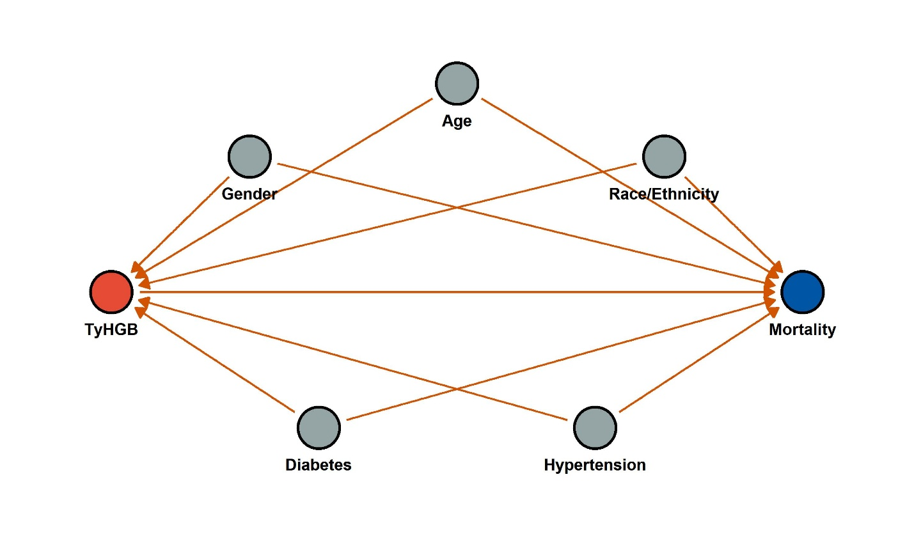
Supplement Figure 1. Directed Acyclic Graph (DAG) for the causal relationship between TyHGB and mortality

Supplement Table 1. Covariance analysis of TyHGB index and other variables with mortality as the outcome.
 | All-Cause Mortality (ACM) |  |  | Cardiovascular Mortality (CVM)
 | GVIF | Df | GVIF^(1/2Df) | GVIF | Df | GVIF^(1/2Df)
TyHGB | 1.24 | 1 | 1.11 | 1.08 | 1 | 1.04
Age | 1.29 | 1 | 1.13 | 1.37 | 1 | 1.17
Gender | 1.17 | 1 | 1.08 | 1.08 | 1 | 1.04
Race/Ethnicity | 1.48 | 2 | 1.10 | 2.08 | 2 | 1.20
Diabetes | 1.94 | 1 | 1.39 | 3.06 | 1 | 1.75
Hypertension | 1.51 | 1 | 1.23 | 2.06 | 1 | 1.43
Df: degrees of freedom; GVIF: generalized variance inflation factor; GVIF^1/(2Df): adjusted generalized variance inflation factor.
Supplement Figure 1 and Supplement Table 1 summarize the potential multicollinearity among the selected covariates, the Generalized Variance Inflation Factor (GVIF) and its adjusted form, GVIF^(1/2Df), were calculated for both the all-cause mortality (ACM) and cardiovascular mortality (CVM) models. In the ACM model, the GVIF values for all covariates ranged from 1.17 to 1.94, with corresponding Adj_GVIF values ranging from 1.08 to 1.39. Similarly, in the CVM model, the GVIF values ranged from 1.08 to 3.06, and the Adj_GVIF values ranged from 1.04 to 1.75. The causal relationships and covariate selection framework were visually mapped using a Directed Acyclic Graph (DAG).
Table 2: Univariate and multivariate Cox regression analysis for TyHGB and other indices
 | Univariate analysis (per 1-SD increase) |  | Multivariate Analysis (per 1-SD increase)
 | HR (95% CIs) | p-value | HR (95% CIs) | p-value
All-cause mortality
TyHGB | 1.123 (1.075-1.174) | <0.001 | 1.160 (1.087-1.239) | <0.001
ABSI | 2.298 (2.033-2.597) | <0.001 | 1.376 (1.202-1.576) | <0.001
WWI | 2.131 (1.933-2.349) | <0.001 | 1.527 (1.350-1.728) | <0.001
WHtR | 1.494 (1.379-1.619) | <0.001 | 1.380 (1.253-1.520) | <0.001
Cardiovascular mortality
TyHGB | 1.099 (1.032-1.171) | 0.003 | 1.137 (1.023-1.263) | 0.017
ABSI | 2.445 (1.988-3.006) | <0.001 | 1.326 (1.021-1.723) | 0.034
WWI | 2.195 (1.817-2.650) | <0.001 | 1.533 (1.193-1.970) | <0.001
WHtR | 1.483 (1.314-1.674) | <0.001 | 1.365 (1.140-1.634) | <0.001
Adjusted by Age, Gender, Ethnicity, Diabetes, Hypertension
The univariate and multivariate Cox proportional hazards regression models evaluating the association between TyHGB and mortality outcomes are presented in Table 2. In the unadjusted models, a 1-SD increase in TyHGB was significantly associated with elevated risks of both all-cause mortality (ACM) and cardiovascular mortality (CVM). Crucially, after adjusting for potential confounders including age and ALT, TyHGB remained a robust independent predictor for both ACM (Adjusted HR = 1.123, 95% CI: 1.075-1.174, p < 0.001) and CVM (Adjusted HR = 1.160, 95% CI: 1.087-1.239, p < 0.001). Similar independent prognostic values were observed for other indices such as ABSI, WWI, and WHtR.

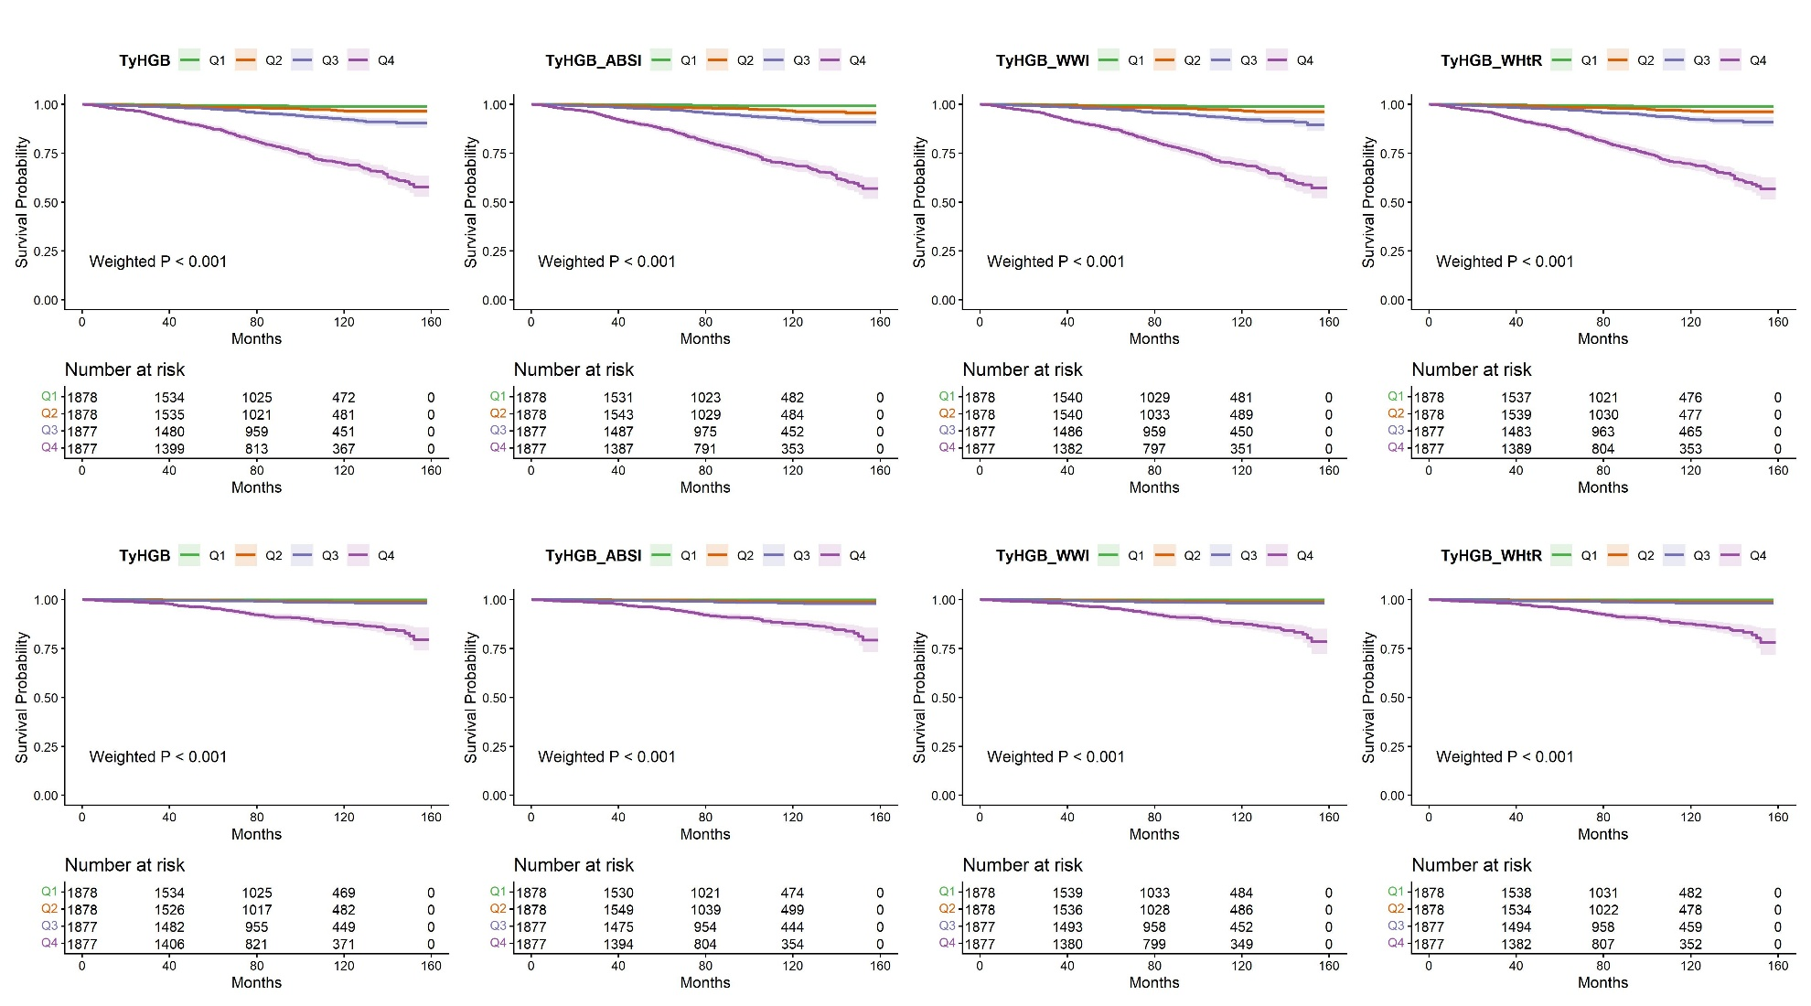
Figure 1: Kaplan-Meier survival curves for all-cause and cardiovascular mortality

Kaplan-Meier survival analysis (Figure 1) illustrated a clear, step-wise deterioration in survival probabilities across increasing TyHGB quartiles. Patients in the highest quartile (Q4) experienced significantly poorer overall and cardiovascular survival rates over the follow-up period compared to those in the lower quartiles. The differences between the survival curves were highly significant across all evaluated index models (Weighted log-rank p < 0.001), visually confirming the long-term prognostic stratification capability of the TyHGB index.
4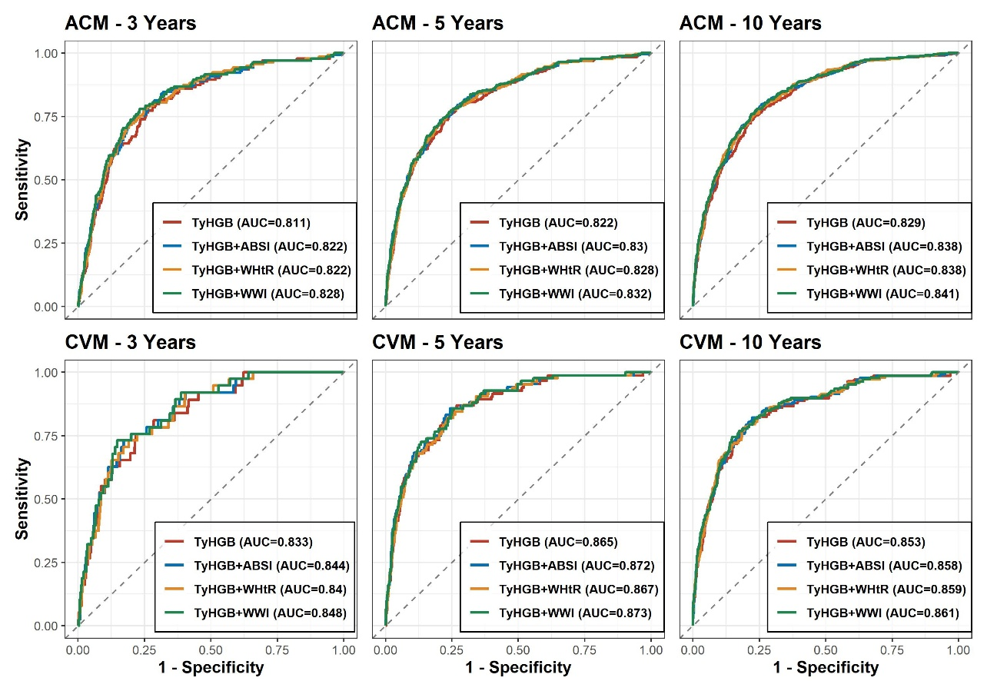
Figure 2: Time-dependent ROC curves for mortality prediction at 3, 5, and 10 years
Time-dependent ROC curves (Figure 2) were constructed to evaluate the predictive accuracy at 3-, 5-, and 10-year intervals. The TyHGB index consistently maintained high Area Under the Curve (AUC) values across all time points for both ACM (AUC ranging from 0.811 to 0.829) and CVM (AUC ranging from 0.833 to 0.865). These findings indicate that the predictive performance of TyHGB is neither transient nor time-limited, but rather provides sustained and robust long-term prognostic accuracy.
Table 3 assesses the incremental predictive value of combining TyHGB with other indices at 10 years. The baseline model incorporating TyHGB alone demonstrated excellent discriminative ability, yielding a C-index of 0.838 for ACM and 0.874 for CVM. The integration of ABSI or WWI into the base model provided marginal but statistically significant improvements in risk reclassification for ACM, as evidenced by the continuous Net Reclassification Improvement (NRI) and Integrated Discrimination Improvement (IDI) metrics (all p < 0.05). However, adding these indices did not result in a statistically significant incremental benefit for the prediction of CVM, suggesting that TyHGB alone is highly sufficient for cardiovascular risk stratification.

Table 3: Incremental predictive value of adding indices to the base model
 | C-index (95% CI) | P-value (DeLong) | Continuous NRI (95% CI) | P-value (NRI) | IDI (95% CI) | P-value (IDI)
All-cause mortality (ACM)
TyHGB | 0.838 (0.811-0.865) |  | Ref |  | Ref
TyHGB + ABSI | 0.841 (0.814-0.867) | 0.902 | 0.003 (0.001-0.009) | <0.001 | 0.009 (0.004-0.017) | <0.001
TyHGB + WWI | 0.841 (0.814-0.868) | 0.885 | 0.005 (0.001-0.010) | 0.020 | 0.011 (0.004-0.019) | <0.001
TyHGB + WHtR | 0.840 (0.813-0.867) | 0.938 | 0.001 (-0.002-0.004) | 0.257 | 0.007 (0.003-0.014) | <0.001
Cardiovascular mortality (CVM)
TyHGB | 0.874 (0.840-0.908) |  | Ref |  | Ref
TyHGB + ABSI | 0.877 (0.846-0.909) | 0.875 | 0.001 (-0.002-0.002) | 0.297 | 0.004 (-0.001-0.013) | 0.277
TyHGB + WWI | 0.879 (0.848-0.910) | 0.830 | 0.001 (-0.001-0.006) | 0.119 | 0.005 (-0.003-0.017) | 0.158
TyHGB + WHtR | 0.876 (0.843-0.908) | 0.933 | 0.001 (-0.002-0.002) | 0.594 | 0.002 (-0.004-0.009) | 0.396

TyHGB and cardiovascular mortality under competing-risk framework
Table 4. Competing risk analysis (Fine-Gray model) for cardiovascular mortality (CVM)
 | Univariate analysis (per 1-SD increase) |  | Multivariate Analysis (per 1-SD increase)
 | sHR (95% CIs) | p-value | sHR (95% CIs) | p-value
TyHGB | 1.098 (1.029-1.172) | 0.005 | 1.133 (1.019-1.260) | 0.021
ABSI | 2.340 (1.912-2.863) | <0.001 | 1.276 (0.982-1.659) | 0.068
WWI | 2.119 (1.756-2.558) | <0.001 | 1.456 (1.132-1.873) | 0.003
WHtR | 1.465 (1.297-1.655) | <0.001 | 1.316 (1.098-1.578) | 0.003
Adjusted by Age, Gender, Ethnicity, Diabetes, Hypertension
Table 4 presents the competing risk analysis using the Fine-Gray proportional subdistribution hazards model for cardiovascular mortality (CVM). In the unadjusted univariate analysis, a 1-SD increase in all evaluated indices (TyHGB, ABSI, WWI, and WHtR) was significantly associated with an elevated risk of CVM (all p < 0.01). However, after adjusting for potential baseline confounders, the TyHGB index remained a robust and independent predictor of CVM (Adjusted sHR = 1.133, 95% CI: 1.019-1.260, p = 0.021). Similarly, WWI and WHtR retained their independent prognostic values. In stark contrast, ABSI completely lost its statistical significance in the multivariate competing risk model (Adjusted sHR = 1.276, 95% CI: 0.982-1.659, p = 0.068). This finding indicates that the initial association of WWI with CVM may be heavily confounded by other baseline covariates or the competing risk of non-cardiovascular death. Overall, these results underscore the independent and robust nature of the TyHGB index in stratifying cardiovascular risk among MASLD patients, even when meticulously accounting for the competing risk of mortality from other causes.
Dose–response relationship and non-linearity analyses

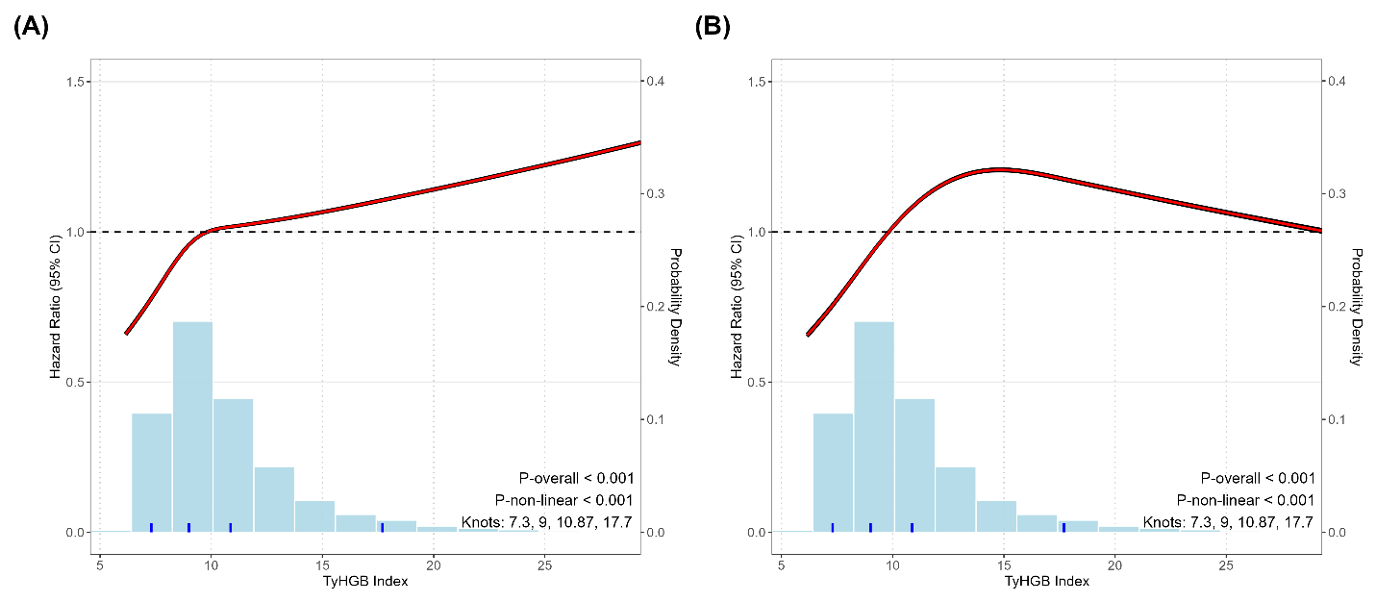
Figure 3: Dose-response relationship between TyHGB and mortality risk in MASLD patients
Restricted cubic spline (RCS) analysis (Figure 3) revealed a significant dose-response relationship between the TyHGB index and the risk of mortality in MASLD patients. A pronounced non-linear association was observed for both ACM and CVM (P-non-linear < 0.001).
Table 5. Threshold effect analysis of TyHGB on ACM and CVM using two-piecewise Cox regression
 | HR (95% CI) | p-value
All-Cause Mortality
Standard linear model | 1.031 (1.017-1.045) | <0.001
Two-piecewise model
TyHGB < 12.1 | 1.115 (1.044-1.192) | 0.001
TyHGB >= 12.1 | 1.019 (1.001-1.036) | 0.034
P for LRT | 0.018
Cardiovascular Mortality
Standard linear model | 1.027 (1.005-1.049) | 0.017
Two-piecewise model
TyHGB < 11.9 | 1.190 (1.045-1.355) | 0.009
TyHGB >= 11.9 | 0.994 (0.943-1.049) | 0.838
P for LRT | 0.020

The threshold effect analysis of the TyHGB index on mortality demonstrated that a two-piecewise Cox regression model provided a superior fit compared to the standard linear model (P for LRT < 0.05 for both ACM and CVM). For all-cause mortality, an inflection point of 12.1 was identified, with a steeper risk increase observed below this threshold (HR 1.115, P = 0.001) compared to the attenuated association above it (HR 1.019, P = 0.034). Similarly, for cardiovascular mortality, a threshold of 11.9 was established; below this level, the risk of cardiovascular death rose significantly (HR 1.190, P = 0.009), while the association was no longer statistically significant beyond this point (HR 0.994, P = 0.838), suggesting a risk saturation effect.
Subgroup and interaction analyses

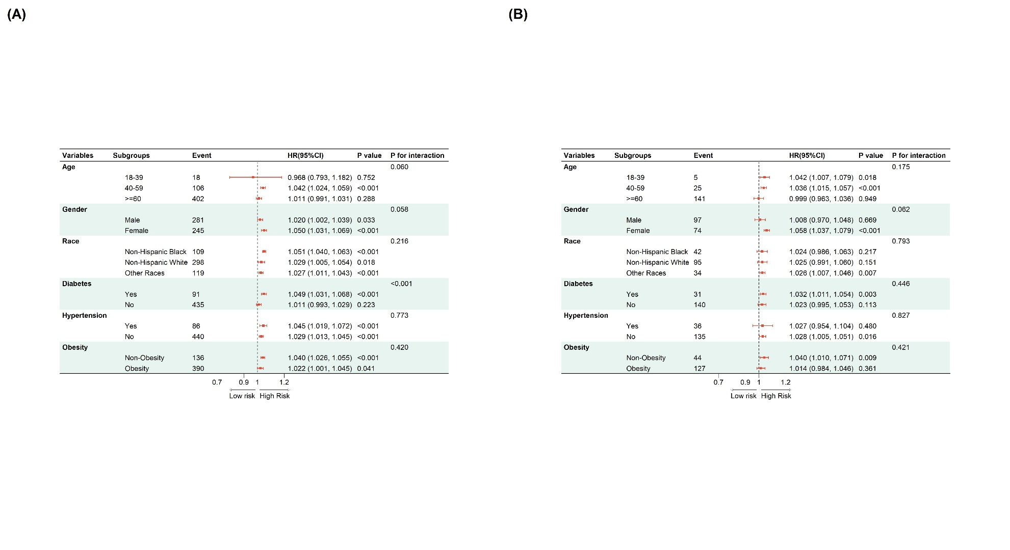
Figure 4: Subgroup analyses of the association between the TyHGB with ACM (A) and CVM (B)
Subgroup analyses, detailed in the forest plots (Figure 4), demonstrated that the prognostic value of TyHGB for mortality was broadly consistent across most demographic and clinical strata. Notably, significant interaction effects were detected for ACM regarding age and baseline diabetes status (P for interaction < 0.05). The association between elevated TyHGB and ACM was particularly pronounced in middle-aged adults (40-59 years) and in patients with preexisting diabetes, suggesting that the vulnerability to TyHGB-related mortality may be exacerbated by these specific clinical contexts.
Mediation analysis through serum uric acid, WBC
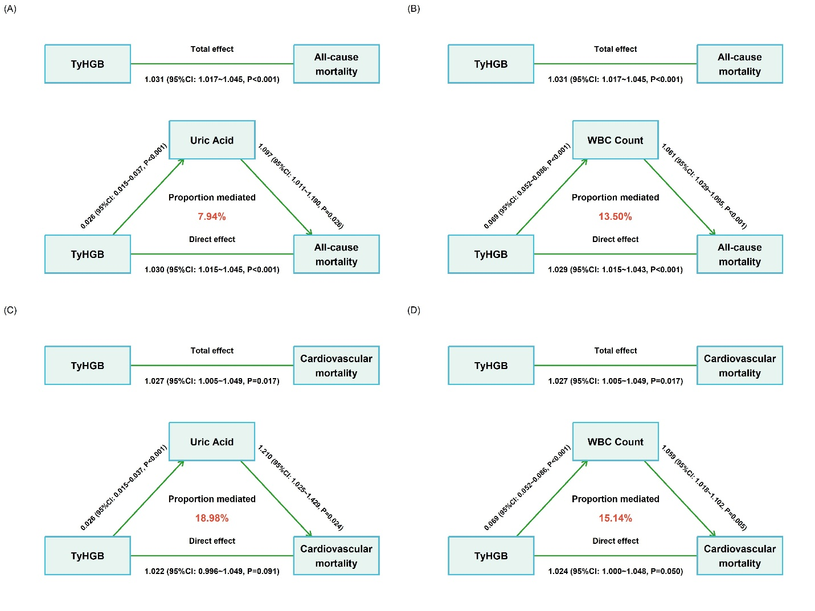
Figure 5: Mediation analysis of the TyHGB index on ACM via uric acid (A) and via WBC (B), on CVM via uric acid (C) and via WBC (D)
Mediation analysis was conducted to quantify the indirect effects of the TyHGB index on mortality outcomes via uric acid and white blood cell (WBC) count. For all-cause mortality, the proportion of the total effect mediated by uric acid was 7.94%, while WBC count mediated 13.50% of the total effect. Regarding cardiovascular mortality, uric acid demonstrated a mediated proportion of 18.98%, and WBC count accounted for 15.14% of the total effect. All indirect pathways (from TyHGB to the mediator, and from the mediator to the outcomes) demonstrated statistical significance across both mortality models.
Supplemental Table 2. Detailed mediation analysis of TyHGB on ACM and CVM via multiple biomarkers
 | ACME |  | ADE |  | Mediated (%)
 | Estimate (95% CI) | p-value | Estimate (95% CI) | p-value
All-Cause Mortality
Uric Acid | 0.002 (0.001-0.005) | 0.045 | 0.029 (0.015-0.044) | <0.001 | 7.94%
WBC Count | 0.004 (0.002-0.006) | <0.001 | 0.029 (0.015-0.042) | <0.001 | 13.50%
AST | 0.001 (-0.001-0.002) | 0.059 | 0.030 (0.016-0.043) | <0.001 | 2.59%
ALT | -0.001 (-0.004-0.003) | 0.756 | 0.031 (0.017-0.044) | <0.001 | 0.00%
Fasting Glucose | 0.022 (0.014-0.030) | <0.001 | 0.005 (-0.014-0.025) | 0.593 | 72.61%
HDL-C | 0.009 (-0.006-0.024) | 0.221 | 0.025 (0.008-0.041) | 0.003 | 29.99%
Cardiovascular Mortality
Uric Acid | 0.005 (0.001-0.010) | 0.044 | 0.022 (-0.004-0.048) | 0.091 | 18.98%
WBC Count | 0.004 (0.001-0.007) | 0.008 | 0.023 (-0.001-0.047) | 0.050 | 15.14%
AST | 0.001 (0.0001-0.003) | 0.024 | 0.025 (0.004-0.047) | 0.022 | 5.19%
ALT | 0.001 (-0.004-0.006) | 0.770 | 0.026 (0.005-0.047) | 0.016 | 2.72%
Fasting Glucose | 0.015 (-0.006-0.036) | 0.156 | 0.010 (-0.024-0.044) | 0.568 | 57.93%
HDL-C | 0.002 (-0.026-0.030) | 0.889 | 0.025 (-0.002-0.051) | 0.068 | 7.50%
ACME: average causal mediation effect; ADE: average direct effect; WBC: white blood cell count
The mediation analysis revealed significant indirect effects of the TyHGB index on mortality mediated through several biomarkers. For all-cause mortality, fasting glucose was the most influential mediator, accounting for 72.61% of the total effect (ACME P < 0.001), followed by WBC count (13.50%) and uric acid (7.94%). Regarding cardiovascular mortality, uric acid and WBC count emerged as the primary mediators, contributing 18.98% (ACME P = 0.044) and 15.14% (ACME P = 0.008) to the total effect, respectively. These findings suggest that systemic metabolic inflammation and glycemic dysregulation are key pathways linking TyHGB levels to adverse mortality outcomes.

Development and validation of TyHGB-based prognostic nomograms

(A) | 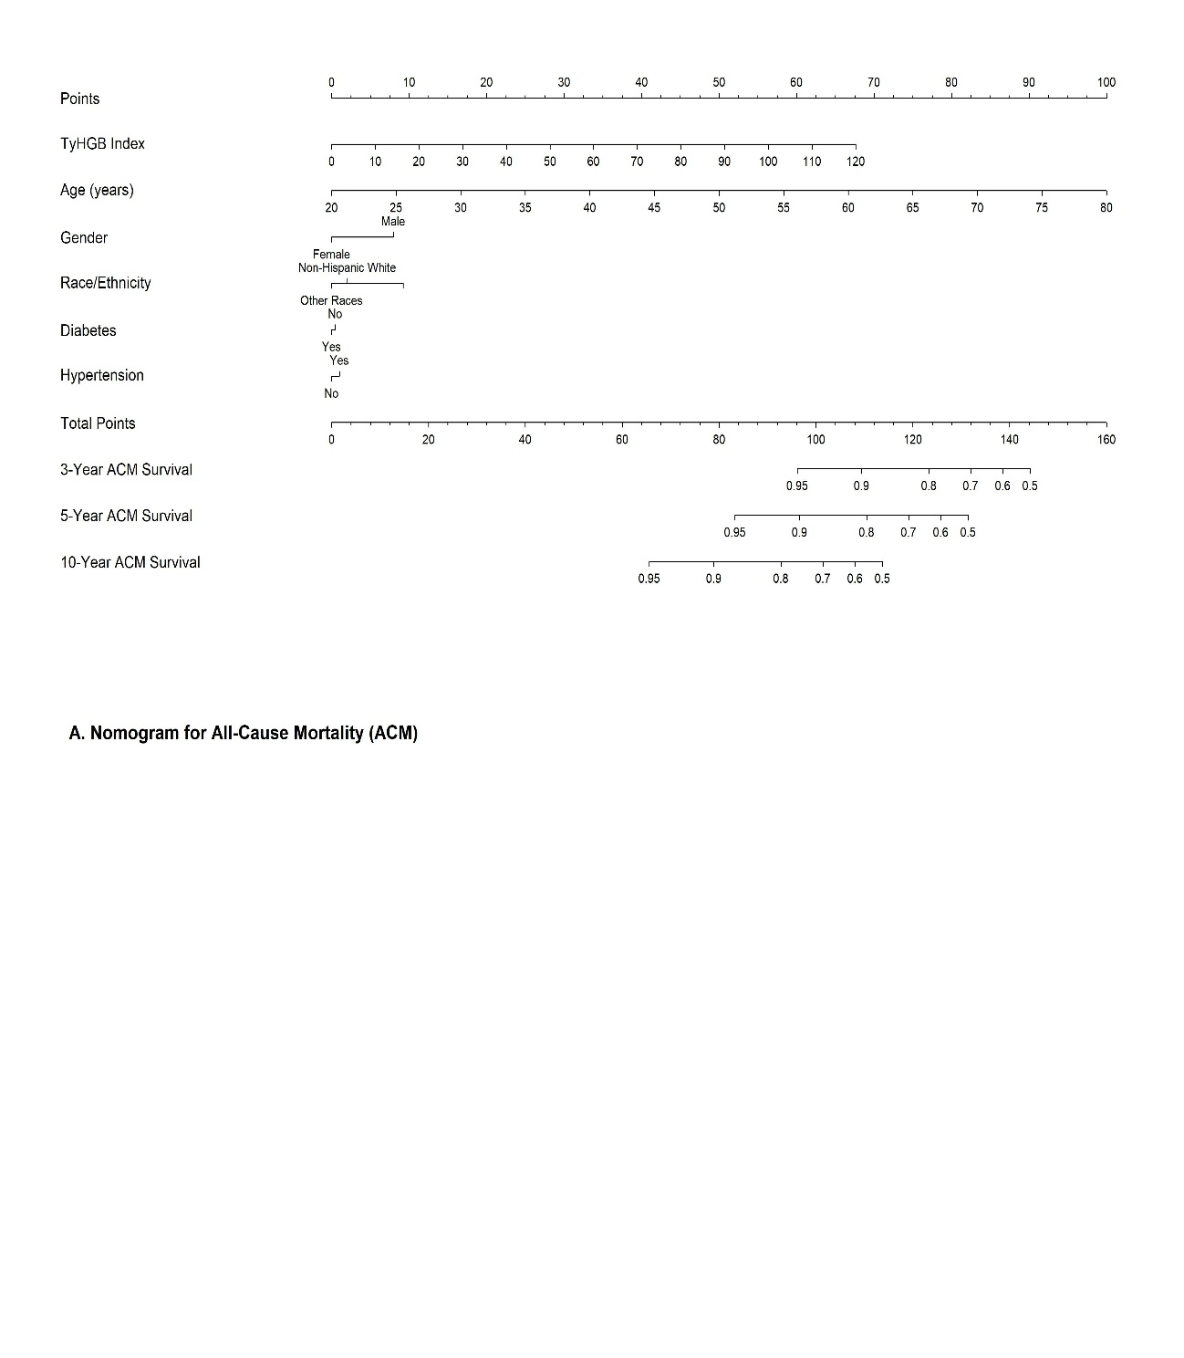
(B) | 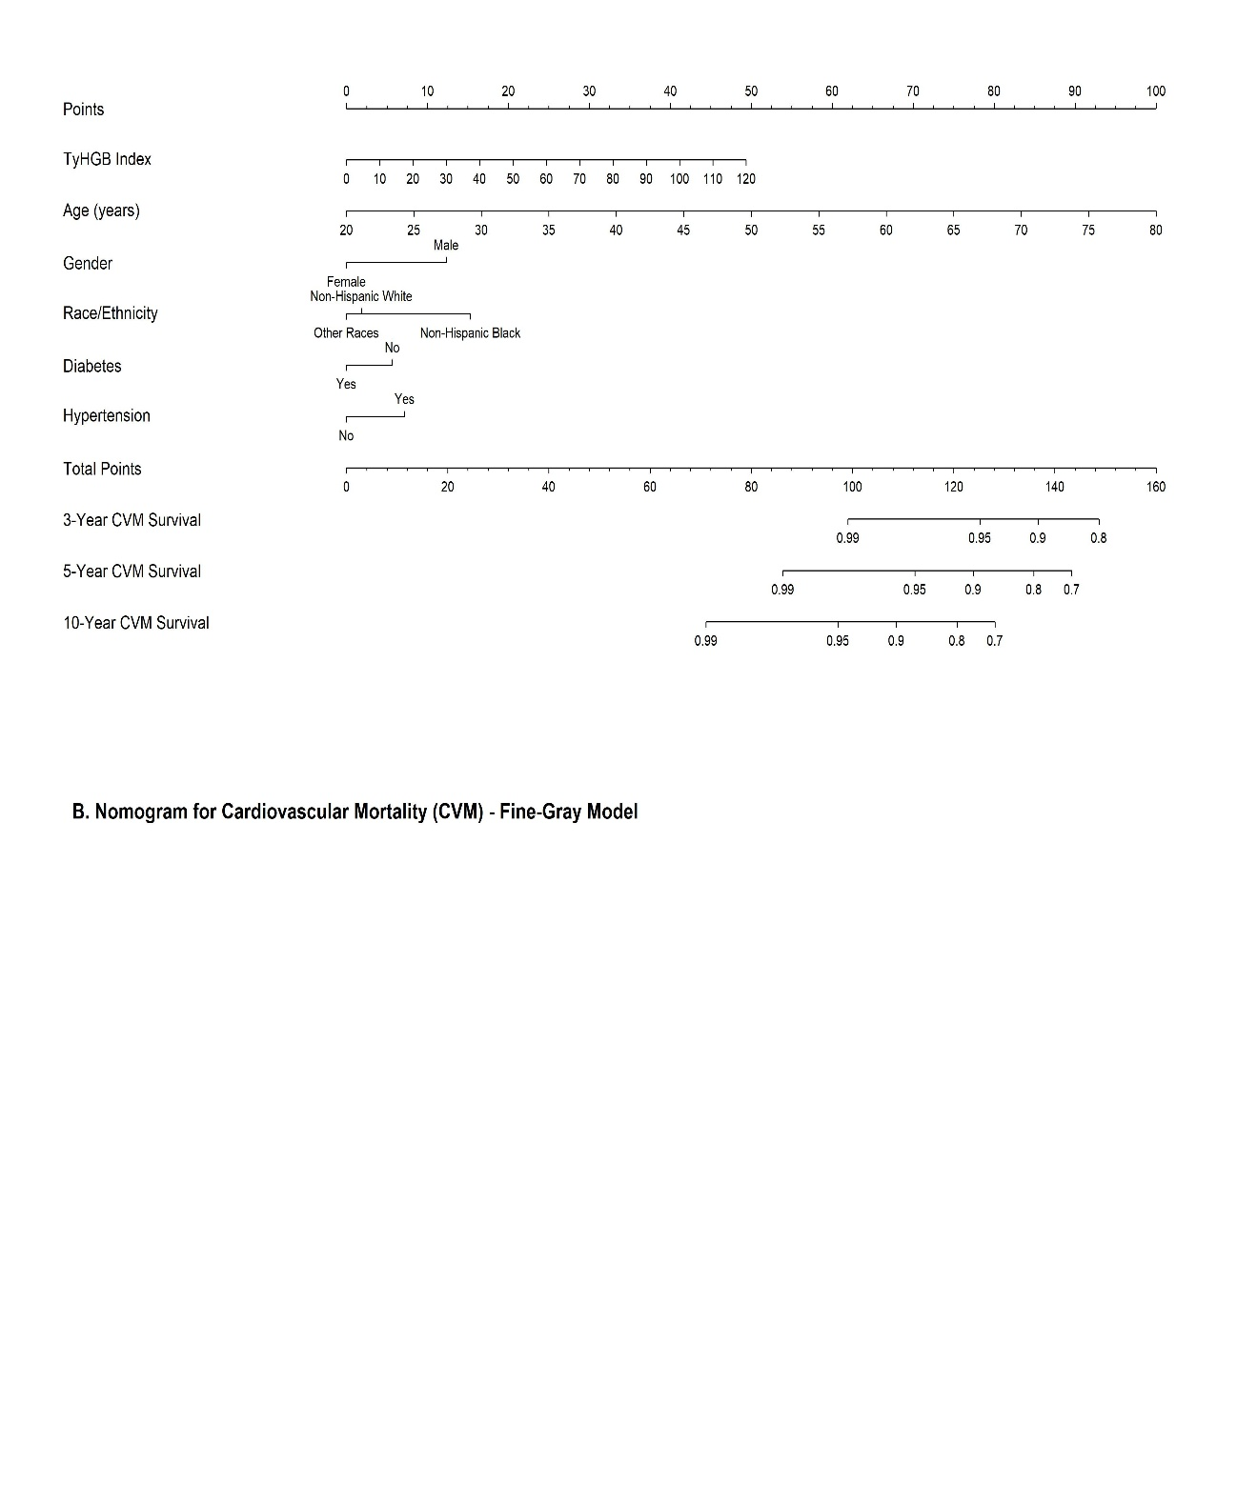
Figure 6. Nomograms predicting 3-, 5-, and 10-year survival probabilities for ACM (A) and CVM (B)
Figure 6 presents the constructed nomograms predicting 3-, 5-, and 10-year survival probabilities for All-Cause Mortality (ACM) and Cardiovascular Mortality (CVM). The models successfully integrate the TyHGB index with baseline demographic and clinical covariates, including age, gender, race/ethnicity, diabetes, and hypertension. Notably, age and the TyHGB index emerge as the dominant prognostic factors, demonstrated by their broad point distribution on the uppermost scales for both ACM and CVM. In contrast, established clinical comorbidities, specifically diabetes and hypertension, exhibit a remarkably narrow point range, indicating that they contribute minimally to the total risk score when the TyHGB index is accounted for in the multivariable models.
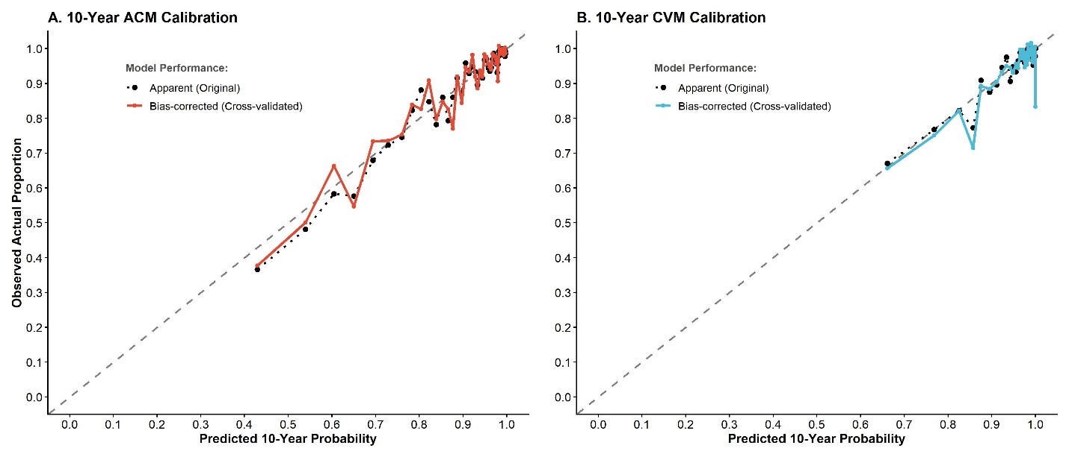
Figure 7. Calibration plots comparing predicted vs observed 10-year mortality risks using 10-fold
Figure 7 displays the calibration plots evaluating the 10-year predictive accuracy of the models using 10-fold cross-validation. For both the ACM (A) and CVM (B) models, the cross-validated, bias-corrected curves demonstrate strong adherence to the ideal 45-degree dashed reference line. This tight alignment indicates a high degree of agreement between the predicted 10-year mortality probabilities and the observed actual proportions, confirming excellent internal calibration and robust model reliability across various risk thresholds.
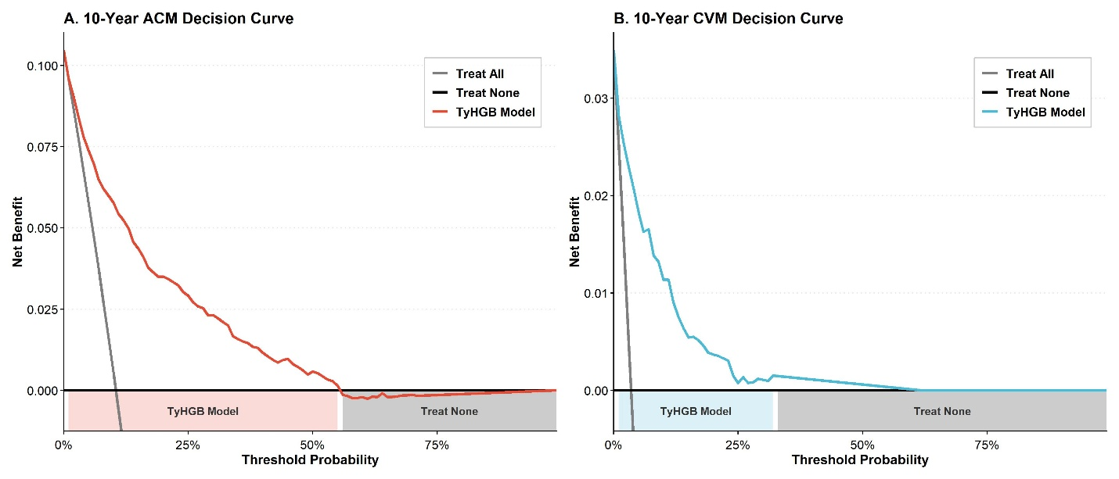
Figure 8. Decision Curve Analysis (DCA) demonstrating the net benefit of the TyHGB clinical model at 10 years
Figure 8 illustrates the Decision Curve Analysis (DCA) assessing the net clinical benefit of the TyHGB model compared to the default "Treat All" and "Treat None" strategies at the 10-year prognostic milestone. In the ACM model (A), the TyHGB clinical tool provides a superior net benefit across a wide spectrum of threshold probabilities, emerging as the optimal strategy from 0% up to approximately 55%. Similarly, for the CVM model (B), the TyHGB model consistently yields a higher net benefit for threshold probabilities ranging from 0% to approximately 30%, beyond which the net benefit converges with the "Treat None" reference line.
Supplemental Table 3. Association between TyHGB and mortality excluding events within the first 24 months
 | Model 1 |  | Model 2 |  | Model 3
 | HR  (95% CI) | p-value | HR  (95% CI) | p-value | HR  (95% CI) | p-value
All-Cause Mortality
Continuous | 1.026 (1.016-1.035) | <0.001 | 1.033 (1.018-1.048) | <0.001 | 1.035 (1.020-1.049) | <0.001
Q1 | Ref. | - | Ref. | - | Ref. | -
Q2 | 1.439 (1.040-1.992) | 0.028 | 1.106 (0.796-1.537) | 0.548 | 1.153 (0.830-1.602) | 0.396
Q3 | 1.940 (1.415-2.660) | 0.000 | 1.296 (0.937-1.791) | 0.117 | 1.386 (0.999-1.922) | 0.051
Q4 | 2.468 (1.743-3.496) | 0.000 | 1.766 (1.271-2.455) | 0.001 | 1.897 (1.350-2.666) | <0.001
P for trend | <0.001 |  | <0.001 |  | <0.001
Cardiovascular Mortality
Continuous | 1.023 (1.010-1.036) | <0.001 | 1.029 (1.007-1.052) | 0.010 | 1.034 (1.013-1.055) | 0.002
Q1 | Ref. | - | Ref. | - | Ref. | -
Q2 | 1.845 (0.931-3.656) | 0.079 | 1.334 (0.663-2.685) | 0.419 | 1.446 (0.725-2.882) | 0.295
Q3 | 1.877 (1.046-3.370) | 0.035 | 1.186 (0.612-2.298) | 0.614 | 1.351 (0.719-2.537) | 0.350
Q4 | 3.155 (1.722-5.781) | 0.000 | 2.116 (1.123-3.986) | 0.020 | 2.432 (1.312-4.508) | 0.005
P for trend | <0.001 |  | 0.017 |  | 0.003
Model 1 unadjusted
Model2 adjusted by Age, Gender
Model3 adjusted by Age, Gender, Ethnicity, Diabetes, Hypertension
To mitigate the potential impact of reverse causality, a sensitivity analysis was conducted by excluding deaths occurring within the first 24 months of follow-up. The prognostic value of the TyHGB index remained robust, with consistently significant hazard ratios across all three adjusted models for both ACM and CVM (P < 0.001). Furthermore, the trend analysis across quartiles confirmed a progressive increase in mortality risk with higher TyHGB levels, particularly in the fourth quartile compared to the first (Model 3: HR 1.897 for ACM; HR 2.432 for CVM; both P < 0.01). The persistent statistical significance of these associations underscores the stability of TyHGB as a reliable independent prognostic indicator.
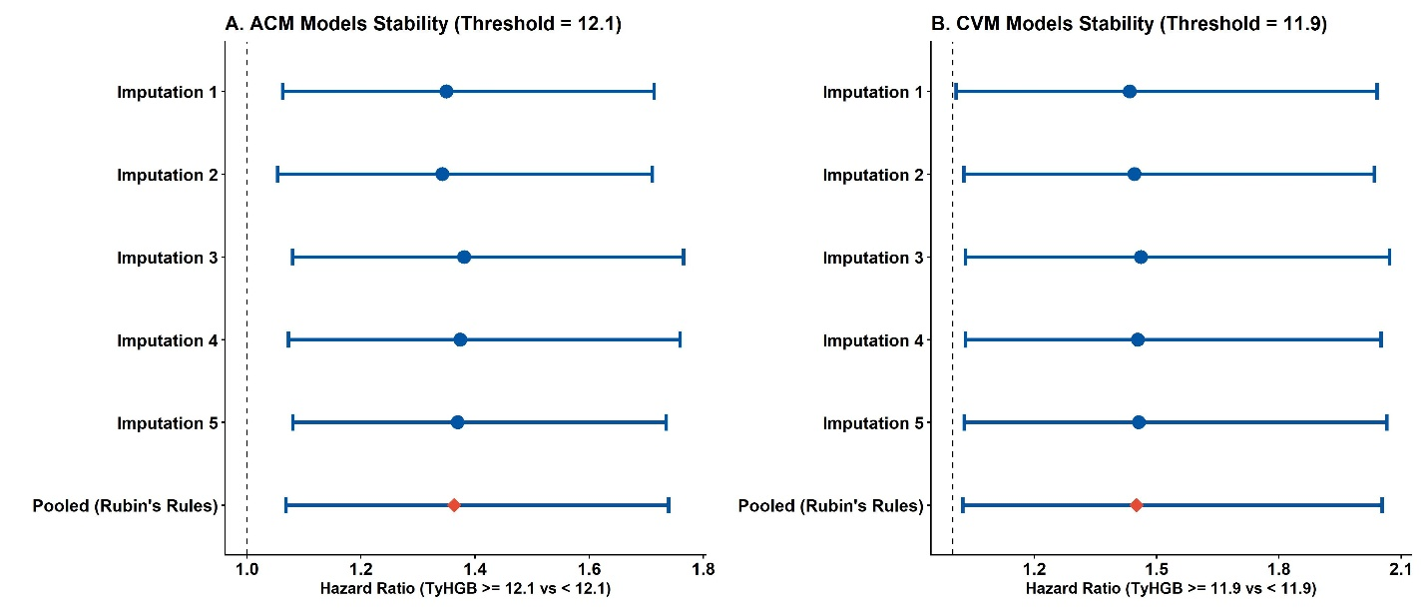
Figure 9. Stability of the TyHGB prognostic value (High vs Low based on threshold) across multiple imputed datasets
The stability of the prognostic value for the dichotomized TyHGB index (categorized as High vs. Low based on calculated thresholds) was evaluated across five multiple imputed datasets. For the ACM model using a threshold of 12.1, and the CVM model using a threshold of 11.9, the estimated hazard ratios remained consistent across all five individual imputations. The pooled hazard ratios, derived using Rubin's rules, showed a stable and significantly increased mortality risk for the high TyHGB groups, with all 95% confidence intervals securely excluding the null value of 1.0.
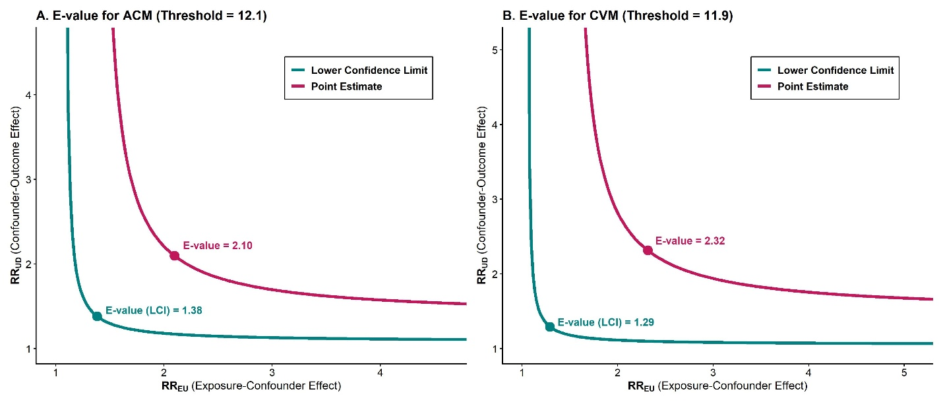
Figure 10. E-value curves for the High vs Low TyHGB index (based on calculated thresholds) on mortality
E-value curves were generated for the dichotomized TyHGB index to assess robustness against unmeasured confounding, utilizing the predefined thresholds of 12.1 for ACM and 11.9 for CVM. In the all-cause mortality model, the point estimate E-value was 2.10, accompanied by a lower confidence limit (LCI) E-value of 1.38. For cardiovascular mortality, the model yielded a point estimate E-value of 2.32, with an LCI E-value of 1.29.
Disscussion
In this nationally representative cohort of US adults with MASLD followed through linkage to the National Death Index, the triglyceride-glucose-haemoglobin (TyHGB) index was independently associated with both all-cause and cardiovascular mortality. Each 1-SD increase in TyHGB conferred an approximately 12% higher hazard for ACM and a 16% higher hazard for CVM after adjustment for demographic and clinical confounders, and the index showed a robust, non-linear dose-response relationship with both endpoints. Discrimination was high and stable over time, with 3-, 5- and 10-year time-dependent AUCs of 0.811-0.829 for ACM and 0.833-0.865 for CVM, and the 10-year C-index of the TyHGB-based model reached 0.838 for ACM and 0.874 for CVM. Together, these results suggest that TyHGB captures clinically meaningful long-term prognostic information in MASLD that is not redundant with established demographic and metabolic predictors.
Biologically, the TyHGB index integrates three converging axes that are central to the cardiometabolic phenotype of MASLD. The TyG component is a well-validated surrogate for insulin resistance and reflects the joint dysregulation of hepatic gluconeogenesis and adipose-tissue lipolysis that fuels ectopic fat deposition. Haemoglobin concentration, in turn, is influenced by iron metabolism, hypoxia-inducible factor signalling, hepcidin and oxidative stress, all of which intersect with hepatic steatosis, endothelial dysfunction and platelet-erythrocyte interactions implicated in atherothrombosis. By combining these dimensions, TyHGB plausibly represents a compact summary of the insulin-resistance-dyslipidaemia-haematology axis that drives adverse cardiovascular outcomes in MASLD. The observation that serum uric acid mediated a substantial proportion (15.49%) of the TyHGB effect on cardiovascular mortality is consistent with a pathway involving purine-metabolism dysregulation, xanthine-oxidase-mediated oxidative stress and endothelial injury, while the smaller mediated proportion for all-cause mortality (3.92%) suggests that additional, non-uric-acid pathways contribute to broader mortality risk.
Our findings extend and connect two strands of literature. First, a growing body of work has linked TyG-based indices to incident diabetes, atherosclerotic cardiovascular disease and mortality in both general and high-cardiovascular-risk populations. Second, haemoglobin and red-cell indices have been associated with metabolic syndrome, insulin resistance, thrombotic risk and adverse cardiovascular outcomes. Within this context, TyHGB can be viewed as a next-generation composite that fuses metabolic and haematological information into a single cardiometabolic risk signal that is particularly relevant in MASLD, a condition that sits at the intersection of hepatic steatosis, insulin resistance and vascular disease.
Compared with established anthropometric indices such as ABSI, WWI and WHtR, TyHGB performed at least as well in our analyses, and the addition of ABSI or WWI to a TyHGB-based model yielded only marginal gains in reclassification for all-cause mortality and no statistically significant improvement for cardiovascular mortality. This pattern argues that, for cardiovascular risk stratification in MASLD, a single composite metabolic–haematological index may be sufficient, without the need to combine multiple anthropometric scores. The non-linear dose–response pattern detected in restricted cubic spline analysis is also clinically informative, suggesting that risk increases more steeply once TyHGB exceeds a threshold. This supports the use of categorical cut-offs (for example, upper-quartile or empirically derived thresholds) for risk communication and case-finding in practice, alongside continuous modelling for statistical efficiency.
From the perspective of cardiovascular diabetology, these results have several clinical and public-health implications. First, MASLD identifies a population in whom cardiovascular events account for a major share of long-term mortality, and a simple biomarker that aggregates triglycerides, fasting glucose and haemoglobin—all routinely measured in primary care—could enhance opportunistic risk stratification without additional cost. Second, subgroup analyses showed that the TyHGB-mortality association was particularly strong in middle-aged adults (40-59 years) and in patients with pre-existing diabetes, two groups in whom intensified cardiometabolic management is most likely to alter long-term outcomes; this supports targeted screening and aggressive multifactorial intervention in these strata. Third, the nomogram, calibration and decision-curve analyses indicate that the TyHGB-based model could plausibly inform individualised 3- to 10-year risk discussion at the point of care, although external validation in independent cohorts is required before clinical deployment.
Strengths of the present study include the use of a large, nationally representative US cohort with rigorous, standardised data collection; survey-weighted analyses that respect the complex sampling design of NHANES; long-term mortality ascertainment through deterministic NDI linkage; direct head-to-head comparison of TyHGB with three contemporary anthropometric indices; and a multi-pronged analytical strategy combining Cox modelling, restricted cubic splines, time-dependent ROC analysis, mediation analysis, internally validated nomograms and decision-curve analysis.
Several limitations should also be acknowledged. First, NHANES is observational, and despite extensive adjustment, residual confounding from unmeasured factors (for example, dietary patterns, physical activity intensity, medication adherence and detailed liver-fibrosis staging) cannot be excluded; our findings should therefore be interpreted as evidence of robust association rather than causation. Second, exposures and covariates were measured at a single baseline visit, so intra-individual variability and trajectory effects of TyG, haemoglobin and other components could not be examined. Third, NHANES does not capture cause-specific cardiovascular subtypes (for example, ischaemic heart disease versus heart failure versus stroke) with full granularity, which limits mechanism-specific inference. Fourth, the MASLD definition relied on the indicators available within NHANES cycles and may differ from histology-based ascertainment used in hepatology cohorts. Fifth, only internal validation through 10-fold cross-validation was performed; external validation in independent multi-ethnic cohorts and in non-US populations is needed before the proposed nomogram can be recommended for routine clinical use.
Conclusion
In a large, nationally representative US adult population with MASLD, the triglyceride-glucose-haemoglobin (TyHGB) index was an independent and clinically meaningful predictor of all-cause and cardiovascular mortality, displaying a non-linear dose-response, stable long-term discrimination and favourable net clinical benefit relative to default decision strategies. By integrating insulin resistance, dyslipidaemia and haemoglobin status into a single, low-cost composite biomarker, TyHGB has the potential to support cardiometabolic risk stratification in MASLD and to inform targeted preventive strategies at the interface of diabetes and cardiovascular disease, pending external validation.

